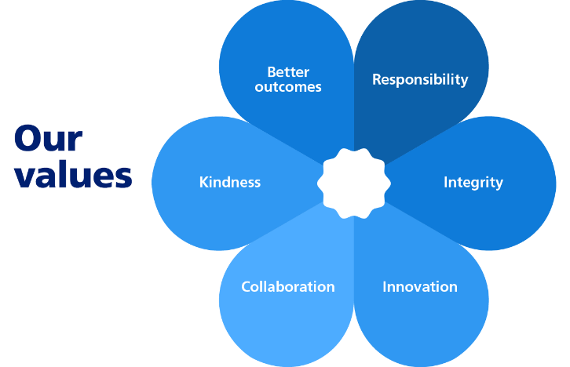
b

DEPARTMENT: Neighbourhoods
JOB TITLE: Tractor Driver / Senior Gardener
SALARY: £26,403 - £28,142

What is the role?

We need you to help maintain and improve the Council’s Sports Pitches and open spaces within the borough. Your main role will be driving a tractor, with relevant attachments, to maintain the Council’s Sports Pitches.

You will:
- Hold a Full Driving Licence and have certification for Tractor Operations
- Be able to select appropriate attachment to complete your daily tasks
- Be competent at connecting and detaching three-point linkage attachments, drawn attachments and PTO shafts
- Know how to mark sports grounds and erect sports equipment
- Carry out daily machinery checks, including fuelling and greasing
- Complete relevant paperwork
- Be flexible to work with other Operations teams if required

You must make sure that you follow our procedures and Health and Safety rules.

You must remember that you represent the Council in all that you do.

You must speak to customers and colleagues in a helpful and polite way.

Sometimes you will need to attend training sessions or work different hours.

Who is the Person?

It is important to us that you have:
- Experience of tractor and/or ride-on mower driving
- Experience in carrying out grounds maintenance duties
- Ideally hold PA1, PA6 pesticide certification
- Knowledge of plant husbandry, horticultural pests and diseases
- Good plant knowledge and an understanding of fine turf culture
- Knowledge on the selection and use of pesticides
- A mature attitude and able to work without close supervision
- A full valid driving licence
- A nice way of speaking to our customers
- The ability to get on well with your team
- A sense of pride and commitment to do a good job
- Common sense and have good judgement
- The ability to work in all weathers and during occasional evenings and weekends

Our policy is to make adaptations for those who have substantial and long term disabilities. If you need an adaptation to carry out any of the above please let us know.

