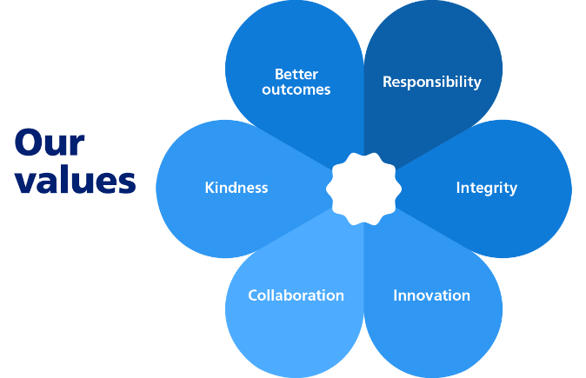


JOB TITLE: Corporate Projects Support Officer
SALARY: Grade 3 (subject to job evaluation)
CONTRACT: Fixed Term – 31 March 2028

What is the role?
You'll provide practical and proactive project support across the Council, helping services deliver a wide range of improvement, change and readiness activities. The role will contribute to ensuring the Council is well prepared for future organisational changes, supporting managers and project leads to organise information, coordinate actions and deliver key pieces of work.
With support and guidance, you will:
- Assist officers and managers across the Council with a variety of projects and service improvement initiatives.
- Research and gather information from teams to help inform project planning and decision making.
- Support the coordination of actions, meetings and workshops connected to Council priorities.
- Maintain project documentation, action plans, trackers and records.
- Monitor progress against agreed actions and remind officers of upcoming deadlines.
- Assist with the preparation of reports, presentations, briefing notes and communications.
- Support reviews of processes, procedures, records and documentation.
- Help services organise, catalogue and maintain information and data.
- Collate and analyse information from a range of sources and present findings in an accessible format.
- Liaise with colleagues across the organisation to gather updates and monitor progress.
- Maintain accurate records and ensure compliance with data protection requirements.
- Provide administrative support for project boards, working groups and meetings.
- Identify opportunities for improved organisation, efficiency and consistency of working practices.
- Understand and contribute to the culture of the organisation so that what is important to the Council is delivered.

Who is the Person?
We need you to enjoy working as part of a close team, be passionate about what you do and strive to make a difference. You'll need to be committed to the Council's values and demonstrate them in all you do.
It is important to us that you have:
- GCSEs (or equivalent) including English and Mathematics.
- Experience of working in an office or administrative environment.
- Good organisational and planning skills.
- Excellent attention to detail.
- Good written and verbal communication skills.
- The ability to work with a wide range of people and build positive working relationships.
- Experience of maintaining accurate records and information.
- The ability to manage several pieces of work at the same time.
- Good problem-solving skills and a practical approach to work.
- Experience of using Microsoft Office applications, including Word, Excel, Outlook and Teams.
- The ability to learn new systems and processes quickly.
- A customer-orientated and non-judgemental approach.
- The ability to work on your own initiative as well as part of a team.
- The ability to remain calm when priorities change.
- A flexible working attitude.
- A simple and straightforward style of verbal and written communication.
- A sense of pride and determination to do a good job.
Our policy is to make adaptations for those who have substantial and long term disabilities. If you need an adaptation to carry out any of the above please let us know.

