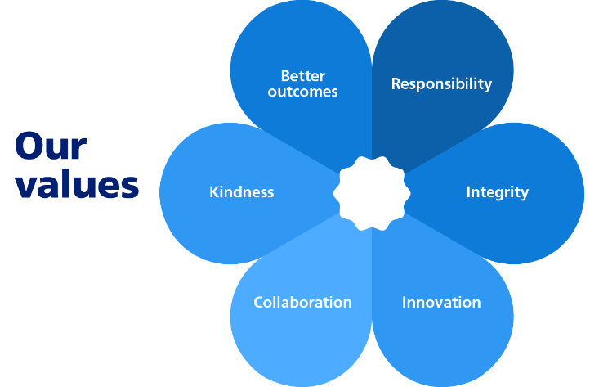


DEPARTMENT: Corporate and Community
JOB TITLE: Senior Project Programme Officer (LGR)
SALARY POTENTIAL: £39,691 - £48,766 based on experience

What is the role?

This is a key corporate role supporting Fareham Borough Council during a period of significant change arising from Local Government Reorganisation (LGR). Working across Council services and in partnership with external organisations, the LGR Senior Project Programme Officer will help coordinate, monitor and support delivery of the Council’s LGR programme, ensuring an effective and well-managed transition to a new Unitary Authority.

The role provides essential high level programme and project support, contributing to planning, tracking progress, managing risks, and preparing reports and briefings for officers, Members and partners. Alongside programme delivery, the post holder will play a central role in contributing to wider cross‑Council working, helping to maintain momentum, clarity and coordination throughout the LGR programme.

This post will:

- Take ownership of agreed LGR projects, using project management expertise to enable their delivery following approved programme arrangements.
- Maintain and update programme documentation including project plans, risk registers and issue logs, escalating issues where appropriate.
- Coordinate programme activity with internal services and partner councils involved in LGR workstreams.
- Prepare and contribute to progress updates, briefings, reports and presentations for senior officers, Members and partner organisations.
- Support LGR‑related data gathering exercises, including contributions to the LGR Data Hub.
- Help coordinate programme work with services whilst ensuring coordination with partner councils
- Monitor relevant LGR policy, guidance and best practice, highlighting implications for Fareham Borough Council.
- Support and delivery of non-LGR projects as required.
- Contribute positively to cross‑Council and corporate working, carrying out other duties commensurate with the grade and purpose of the role.
- Monitor relevant developments in LGR policy, guidance or best practice and highlight implications for Fareham where appropriate.

Who is the person?

The successful candidate will:

- Proven expertise and experience of project management planning, control and delivery for significant programmes or projects within a local government or public sector environment.
- Extensive experience of briefing senior managers, partners or elected Members on complex or sensitive issues.
- Possess strong written and verbal communication skills, with the ability to produce clear, concise reports, briefings and engagement outputs.
- Be well organised, with the ability to manage multiple tasks, deadlines and competing priorities.
- Have good analytical skills, with the ability to interpret information and present balanced, evidence‑based conclusions.
- Be confident working with a wide range of stakeholders, including residents, officers, Members and partner organisations.
- Be proficient in using Microsoft Office applications.
- Show a proactive, adaptable and collaborative approach.

Additional Information

- This role is offered on a fixed term basis linked to the LGR programme

Last Updated: July 2026

Our policy is to make adaptations for those who have substantial and long-term disabilities. If you need an adaptation to carry out any of the above, please let us know.

